**Automated Meeting Room Booking System**

Contents

System Overview 1

User Guide 2

Accessing the System 2

Real-time Room Availability 2

System Architecture 2

Loose Coupling 2

Component Overview 3

Data Flow 4

Technical Details 6

Security Measures 6

Maintenance and Updates 6

## System Overview

The Automated Room Booking System is a software solution that streamlines the process of reserving meeting rooms. It offers an intuitive user interface and various features to enhance efficiency in scheduling meetings and booking appropriate meeting spaces.

* Benefits of the Automated Room Booking System
* User-friendly interface for effortlessly creating and configuring meeting rooms.
* Managers can easily search for and book meeting rooms that match their specific meeting requirements.
* The system prevents double bookings, reducing scheduling conflicts and enhancing efficiency.
* An intuitive and user-friendly interface makes the system accessible to all users, regardless of their technical proficiency.
* Real-time room availability information is provided to managers, allowing them to make informed booking decisions.

## User Guide

### Accessing the System

To access the Automated Room Booking System, follow the steps outlined in your organization's specific setup and login procedures.

* Creating and Configuring Meeting Rooms
* Access the system as an administrator.
* Navigate to the "Meeting Rooms" section.
* Add meeting rooms by specifying their names, seating capacity, and at least two amenities.
* The system will calculate per-hour charges automatically.
* A unique ID is generated for each meeting room.
* Searching and Booking Meeting Rooms
* Log in to the system with your credentials.
* Access the "Booking" or "Reservations" section.
* Enter your meeting details, including date, time, duration, and the number of participants.
* The system will display available meeting rooms that meet your criteria.
* Choose a room and confirm the booking.

Preventing Double Bookings

The system is designed to prevent double bookings by checking room availability in real-time. If a room is already booked for the selected date and time, it will not be available for further bookings.

### Real-time Room Availability

Managers have access to real-time room availability information, allowing them to make informed booking decisions based on current availability.

## System Architecture

### Loose Coupling

The system employs a loose coupling architecture to minimize dependencies between different components. This design enhances flexibility, maintainability, and ease of understanding. It allows for changes in one part of the system without affecting others, and it isolates failures to specific components, making issue identification and resolution easier.

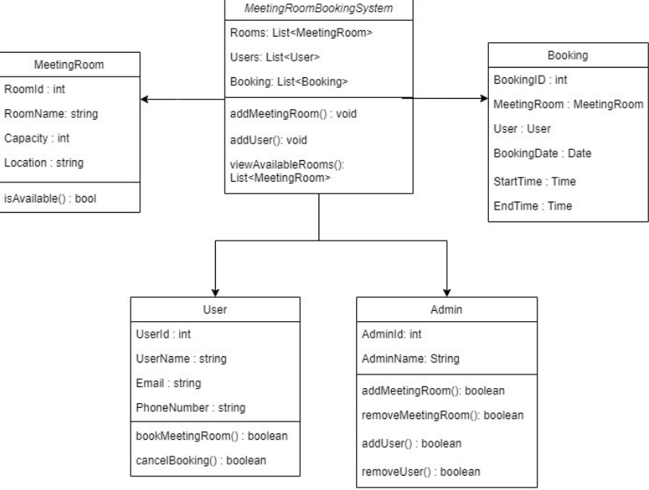

Class Diagram

### Component Overview

The system comprises several components that work together seamlessly to facilitate meeting room bookings. These components include the user interface, database, booking engine, and authentication system.

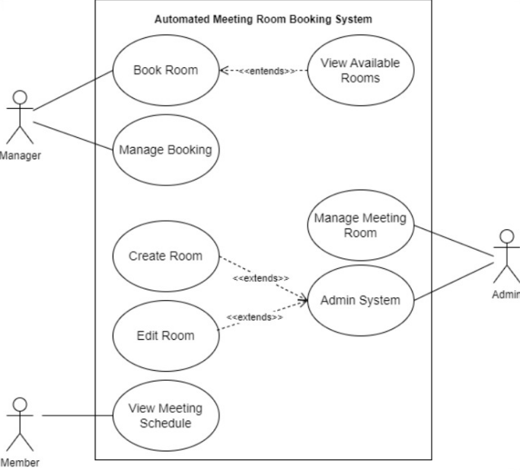

Use Case Diagram

### Data Flow

Data flows through the system from user input to the database and back to the user interface. The system's loose coupling ensures that data is transferred efficiently between components.

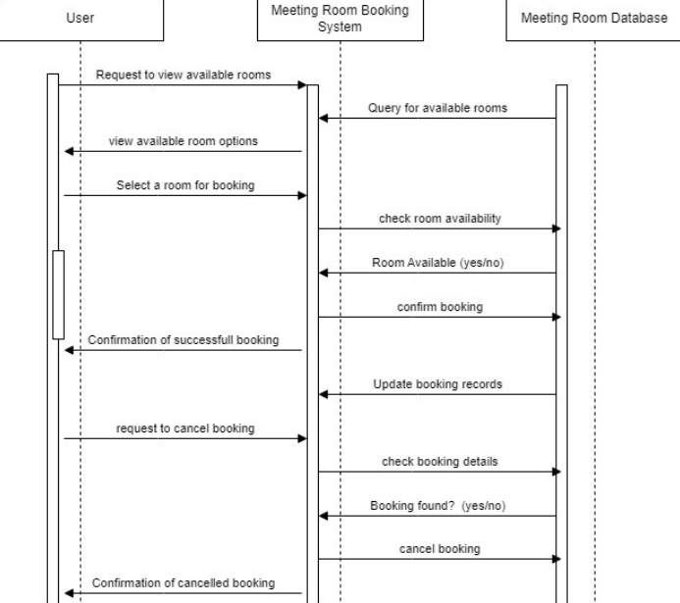

Sequence Diagram

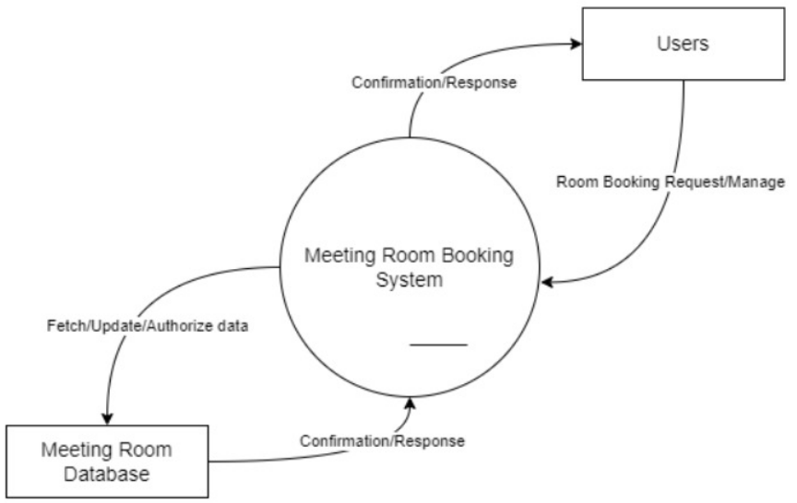

Context Diagram

## Technical Details

The Automated Room Booking System is built using a stack of modern technologies,

1. Java
2. JavaScript
3. HTML
4. CSS

## Security Measures

The system prioritizes security by implementing best practices, ensuring that user data and booking information are protected.

## Maintenance and Updates

Regular maintenance and updates are essential to keep the system running smoothly.